National University of Computer and Emerging Sciences, Lahore Campus



**MG2009 – Data Analysis for Business-II Project ( Fall 2024 )**

**Submitted To : Ms.Aroosa Safdar**

**Investigating the impact of Remote Work on Mental Health.**

A

**BSBA:**

**Submitted By:**

**( 23l-5047 ) Amna Azfar**

**Acknowledgements**

First and foremost, we would like to thank our instructor Dr. Komal Nadeem for an opportunity to not only learn but also to apply the concepts that we have learned. We are sincerely grateful to her and her efforts.

Then, we would like to offer much thanks to all the participants of our study, for their valued time and their much-appreciated opinions that allowed us to carry out our research and conduct our analysis. We would not have been able to complete our project without them.

We have so much gratitude for all those that contributed. Many thanks.

**Table of Contents:**

ACKNOWLEDGMENTS ................................................................................................................. 2

1. INTRODUCTION ................................................................................................................4-5
2. OBJECTIVES OF THE STUDY ………............................................................................. 6
3. DATA COLLECTION AND METHODOLOGY................................................................ 7
4. RESEARCH APPROACH …………………………………………………………………8
5. ANALYSIS AND RESULTS ................................................................................................ 9
6. SUMMARIES …………………………………….………………………………………...10
7. CONCLUSION .................................................................................................................... 14
8. LIMITATIONS OF THE STUDY....................................................................................... 15
9. GRAPHICAL REPRESENTATION ................................................................................... 18
10. QUESTIONNAIRE ….......................................................................................................... 25
11. SAMPLE OF 5 QUESTIONNAIRE ............................. ....................................................... 28

**List of Tables**

Table 1……………………………………………………………………………………………11

Table 2……………………………………………………………………………………………12

Table 3……………………………………………………………………………………………13

Table 4……………………………………………………………………………………………14

Table 5……………………………………………………………………………………………16

Table 6……………………………………………………………………………………………17

Table 7……………………………………………………………………………………………18

Table 8……………………………………………………………………………………………20

Table 9...………………………………………………………………………………………….20

Table 10.………………………………………………………………………………………….22

Table 11...……………………………………………………………………...…………………24

**List of Figures**

Figure 1…………………………………………………………………………………………...11

Figure 2…………………………………………………………………………………………...12

Figure 3…………………………………………………………………………………………...13

Figure 4…………………………………………………………………………………………...14

Figure 5……………………………………………………………………………………….…..15

Figure 6………………………………………………………………………………………...…16

Figure 7………………………………………………………………………………………...…17

Figure 8……………………………………………………………………………………………19

Figure 9……………………………………………………………………………………………19

Figure 10..…………………………………………………………………………………………22

Figure 11..…………………………………………………………………………………………24

**INTRODUCTION:**

We are pleased to introduce you to our Education System Data Analysis survey, which aims to gather valuable insights from all stakeholders involved in the educational ecosystem. As we strive to provide an excellent educational experience, we recognize the critical role of regularly assessing and addressing the diverse needs and perceptions of everyone involved. This survey is an essential tool that will help us understand the various facets of the educational experience, and we welcome your feedback as a student, parent, educator, or any other essential stakeholder.

Our primary objective is to gain a comprehensive understanding of the educational landscape through a multifaceted approach. We strive to measure students' satisfaction levels across various dimensions of their educational journey, including teaching quality, resource availability, extracurricular opportunities, and effectiveness of support services. Our goal is to capture a holistic perspective of students' experiences as they navigate their educational pathways.

In addition to assessing student satisfaction, our survey also aims to evaluate how well our education system is preparing students for success in a constantly changing world. This involves examining the relevance of the curriculum to real-world situations, the quality of support and guidance provided by teachers and academic advisors, and the inclusivity and accessibility of educational environments. By exploring these crucial areas, we hope to determine how effectively our educational institutions are equipping students with the necessary skills and knowledge to navigate the challenges and opportunities of the future.

At our organization, we believe in promoting diversity of perspectives in our analysis. To achieve this, we actively seek feedback from parents and educators. This helps us to better understand their views on topics such as communication, involvement in education, professional development opportunities, and disciplinary policies. By doing so, we aim to incorporate a wide range of perspectives in our analysis and provide a comprehensive understanding of the educational landscape.

Ultimately, the overarching goal of this survey is to identify both the strengths and areas for improvement within our educational institutions. By leveraging the insights garnered through this process, we can collaboratively work towards creating an environment that nurtures learning, fosters growth, and cultivates success for all members of the educational community.

We extend our sincere gratitude to you for taking the time to participate in this survey. Your feedback is invaluable, and together, we can embark on a collective journey towards shaping a brighter and more inclusive future for education.

**KEY OBJECTIVES:**

* **Evaluate Student Satisfaction:** Assess students' satisfaction across teaching quality, resources, extracurricular, and support services to identify areas of strength and improvement.
* **Assess Curriculum Relevance and Preparedness:** Evaluate curriculum alignment with real-world scenarios, quality of support, inclusivity, and accessibility to enhance students' preparedness for future challenges.
* **Incorporate Diverse Perspectives:** Gather feedback from parents and educators to diversify insights on communication, involvement, professional development, and disciplinary policies, enriching our analysis of the educational landscape.

**DATA COLLECTION AND METHODOLOGY:**

To comprehensively grasp the educational landscape and stakeholders' viewpoints, a thorough data collection method was employed, utilizing a survey approach. This survey was meticulously crafted to cover various aspects of the educational journey, seeking input from students and educators.

The survey was disseminated widely across online platforms like social media, email, and educational forums to ensure broad participation. Participation was entirely voluntary, emphasizing candid responses, and anonymity was maintained to encourage honesty.

The questionnaire encompassed demographics, educational experiences, satisfaction levels, and suggestions for improvement. Statistical tools were utilized for robust data analysis, providing valuable insights into the educational ecosystem.

While the survey method facilitated efficient data collection and encouraged genuine responses, its reliance on online platforms may have excluded certain demographics. Additionally, self-reported data could be influenced by biases or recall errors, and the snapshot nature of the survey may not capture longitudinal changes.

Despite these limitations, the survey method effectively captured diverse perspectives on education. To address shortcomings and deepen understanding, future research could explore additional data collection methods for a more comprehensive analysis.

**Research Approach**

A questionnaire was devised with 11 questions. These questions ranged from some personal information about the participant (Email, Gender) to additional questions for attaining the purpose of our study.

The Questionnaire was made with the assistance of Google Forms and was randomly sent out to people- which friends, acquaintances and strangers filled out. All of this was done online via the use of different Social Media accounts of each person contributing to the study.

After the responses were collected, the data gathered was accumulated in a single Excel File which holds complete detail about each of the respondents and their responses to the questionnaire devised, respectively.

Both a Qualitative and Quantitative method of research has been considered as seen fit for each Hypothesis/Objective.

**ANALYSIS AND RESULTS:**

The questionnaire employs a Likert Scale spanning from 1 to 5, incorporating responses ranging from "Very Unlikely" to "Very Likely." This scale functions as an Ordinal Statistical Scale, indicating a discernible order or ranking among the response options, facilitating meaningful comparisons. However, it's noteworthy that the intervals between each value may not uniformly convey the same degree of significance. Nonetheless, respondents' selections can be systematically arranged from the least to the most favorable or probable. Furthermore, the Likert Scale is characterized as a discrete variable, implying that it delineates distinct levels or categories represented by whole numbers. In essence, respondents are constrained to select from predefined options without the liberty to specify values between them.

**Gender:**

The survey analysis indicated a higher frequency of female participants compared to male participants. Specifically, out of the total respondents, 32 were identified as female, whereas 28 were male, signifying a distribution of 53% females and 47% males. Consequently, the participation of female students exceeded that of male students. Moreover, it's noteworthy that both the median and mode of the participant gender were female, suggesting that female respondents were not only more numerous but also tended to cluster around the most common gender category in the survey.

|  |  |  |  |  |  |  |
| --- | --- | --- | --- | --- | --- | --- |
| **Frequency Table** | | | | | | |
| **Gender** | **Frequency** | **Relative Frequency** | **Percentage Frequency** | **Cummulative Frequency** | **Mode** | **Median** |
| **Male** | 28 | 0.466666667 | 46.6666667 | 28 | Female | Female |
| **Female** | 32 | 0.533333333 | 0.53333333 | 60 |  |  |
| **Total** | 60 | 1 | 100 |  |  |  |
|  |  |  |  |  |  |  |

*Table1*

*Figure1*

**Semester:**

The Data showed that the highest frequency of students were from **Semester 2** which was about 48% of the total participants.

|  |  |  |  |  |  |
| --- | --- | --- | --- | --- | --- |
| **Frequency Table** | | | |  |  |
| **Semester** | **Frequency** | **Relative Frequency** | **Percent Frequency** | **Mean** | **3.683333** |
| **1** | 4 | 0.066666667 | 6.666666667 | **Median** | **2** |
| **2** | 29 | 0.483333333 | 48.33333333 | **Mode** | **2** |
| **3** | 1 | 0.016666667 | 1.666666667 |  |  |
| **4** | 9 | 0.15 | 15 |  |  |
| **5** | 1 | 0.016666667 | 1.666666667 |  |  |
| **6** | 6 | 0.1 | 10 |  |  |
| **7** | 1 | 0.016666667 | 1.666666667 |  |  |
| **8** | 9 | 0.15 | 15 |  |  |
| **Total** | 60 | 1 | 100 |  |  |

*Table2*

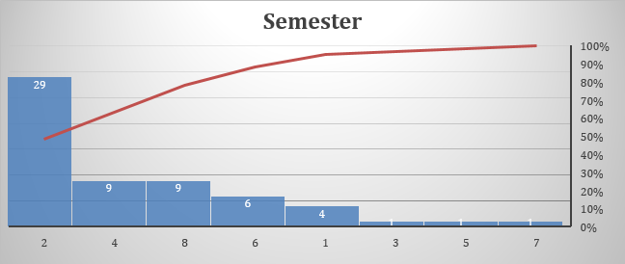

*Figure2*

**Department:**

The analysis revealed that the majority of students belonged to the BS-BA and BS-DS programs. Specifically, there were 23 BS-BA students, comprising 38 % of the total participants. Additionally, there were 16 BS-DS students, accounting for 26 % of the total participants. This distribution highlights a significant representation of these two programs among the surveyed students.

|  |  |  |  |  |  |
| --- | --- | --- | --- | --- | --- |
| **Values** | **Frequency** | **Relative Frequency** | **Percentage Frequency** | **Angular. F** | **C.F** |
| **BS(BA)** | 23 | 0.383333333 | 38.33333333 | 138 | 23 |
| **BS(DS)** | 16 | 0.266666667 | 26.66666667 | 96 | 39 |
| **BS(CS)** | 7 | 0.116666667 | 11.66666667 | 42 | 46 |
| **BS(AF)** | 2 | 0.033333333 | 3.333333333 | 12 | 48 |
| **BBA** | 2 | 0.033333333 | 3.333333333 | 12 | 50 |
| **BS(SE)** | 1 | 0.016666667 | 1.666666667 | 6 | 51 |
| **Other** | 9 | 0.15 | 15 | 54 | 60 |
|  | 60 | 1 | 100 | 360 |  |

*Table3*

*Figure3*

**Satisfaction Rate:**

According to the data, out of the total 60 participants, 23 students, representing 38 % of the sample, expressed satisfaction with their university education by giving it a rating of 4. This indicates a substantial proportion of the respondents who are content with their educational experience. Additionally, 21 students, constituting 35 % of the total participants, expressed a neutral stance, rating their satisfaction level as 3. This suggests that a significant portion of the surveyed students neither strongly agree nor disagree with their educational experience, indicating a range of sentiments among participants.

|  |  |  |  |  |  |
| --- | --- | --- | --- | --- | --- |
| **Frequency Table** | | | | |  |
| **Scale** | **Values** | **Frequency** | **Comulative Frequency** | **Relative Frequency** | **% Frequency** |
| **Very dissatisfied** | **1** | 6 | 6 | 0.1 | 10 |
| **Dissatisfied** | **2** | 5 | 11 | 0.083333333 | 8.333333333 |
| **Neutral** | **3** | 21 | 32 | 0.35 | 35 |
| **Satisfied** | **4** | 23 | 55 | 0.383333333 | 38.33333333 |
| **Very Satisfied** | **5** | 5 | 60 | 0.083333333 | 8.333333333 |
|  |  | 60 |  | 1 | 100 |

*Table4*

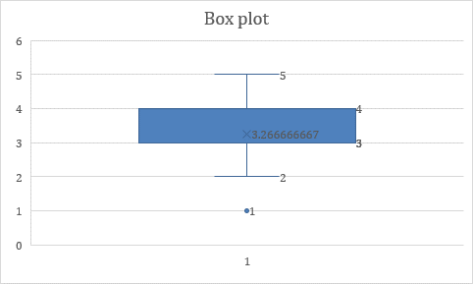 *Figure4*

**Extra-Curricular Activities:**

The survey suggests that most students are actively engaged in extracurricular activities. About 62 % of participants responded with a "Yes" indicating their involvement, while 38 % responded with a "No". This indicates that the highest percentage of participants in the survey are indeed participating in extracurricular activities.

Furthermore, it's notable that both the mode and median responses were "Yes". This not only highlights the popularity of extracurricular activities among respondents but also suggests that "Yes" was not just the most frequent response but also the central tendency within the data set.

|  |  |  |  |  |  |  |  |
| --- | --- | --- | --- | --- | --- | --- | --- |
| **Values** | **Frequency** | **R.F** | **P.F** | **A.F** | **C.F** | **Mode** | **Median** |
| **Yes** | 37 | 0.616667 | 61.66667 | 222 | 37 | Yes | Yes |
| **No** | 23 | 0.383333 | 38.33333 | 138 | 60 |  |  |
| **Total** | 60 | 1 | 100 | 360 |  |  |  |

*Table5*

*Figure5*

**Rating for Teaching Methods:**

The survey data indicates that out of 60 participants, 27 students rated their satisfaction with the teaching methods as a 4, which accounts for 45% of the total participants. This suggests a sizable proportion of students who are content with the teaching methods being utilized.

Additionally, 20 students responded neutrally with a rating of 3 for their satisfaction level, constituting 33% of the total participants. This indicates a significant number of students who neither strongly agree nor disagree with the teaching methods, showcasing a diverse range of perspectives among the surveyed individuals.

Furthermore, it's noteworthy that the mode of the data, indicating the most frequently occurring response, was a satisfaction rating of 4. This suggests that the majority of participants expressed satisfaction with the teaching methods, reinforcing the notion of contentment among a significant portion of the surveyed students.

|  |  |  |  |  |  |
| --- | --- | --- | --- | --- | --- |
| **Frequency Table** | | | | |  |
| **Scale** | **Values** | **Frequency** | **Comulative Frequency** | **Relative Frequency** | **% Frequency** |
| **Very dissatisfied** | **1** | 5 | 5 | 0.083333333 | 8.333333333 |
| **Dissatisfied** | **2** | 5 | 10 | 0.083333333 | 8.333333333 |
| **Neutral** | **3** | 20 | 30 | 0.333333333 | 33.33333333 |
| **Satisfied** | **4** | 27 | 57 | 0.45 | 45 |
| **Very Satisfied** | **5** | 3 | 60 | 0.05 | 5 |
|  |  | 60 |  | 1 | 100 |

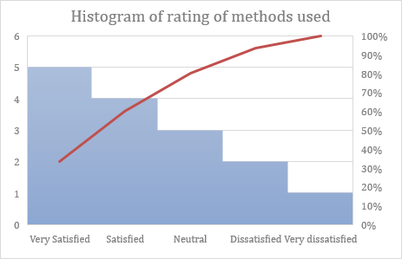 *Table6*

*Figure6*

**Quality of Resources Provided:**

The ratings provided by the participant’s highlight that a majority of the students had a neutral stance regarding the quality of resources offered by their university. Specifically, 26 out of 60 students rated their satisfaction level as 3, indicating a neutral sentiment. This group constitutes 43% of the total participants, indicating a significant proportion of students who neither strongly agree nor disagree with the quality of resources provided.

In contrast, 18 students rated their satisfaction level as 4, indicating satisfaction with the quality of resources offered by the university. This group accounts for 30% of the total participants, reflecting a smaller proportion of students who are content with the resources provided. Overall, the data suggests that a larger portion of the surveyed students are neutral about the quality of resources offered by their university, with a smaller percentage expressing satisfaction.

Moreover, the mean satisfaction rating, calculated at 3.283, indicates a moderate overall sentiment among respondents regarding the quality of university resources. Furthermore, both the median and mode ratings, which are also 3, reinforce the prevalence of a neutral stance within the dataset, emphasizing the consistent trend towards neutrality in students' perceptions.

|  |  |  |  |  |  |  |
| --- | --- | --- | --- | --- | --- | --- |
| **Frequency Table** | | | | | | |
| **Values** | **Frequency** | **C. Frequency** | **Relative Frequency** | **% Frequency** | **Mean** | **3.283333** |
| **1** | 6 | 6 | 0.1 | 10 | **Median** | **3** |
| **2** | 3 | 9 | 0.05 | 5 | **Mode** | **3** |
| **3** | 26 | 35 | 0.433333333 | 43.33333333 |  |  |
| **4** | 18 | 53 | 0.3 | 30 |  |  |
| **5** | 7 | 60 | 0.116666667 | 11.66666667 |  |  |
|  | 60 |  | 1 | 100 |  |  |

*Table7*

*Figure7*

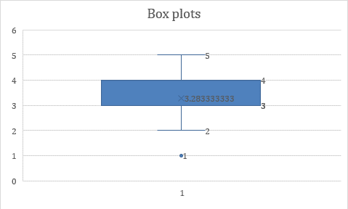*Figure8*

**Rating for Recommendation:**

According to the data, a majority of students expressed a likelihood to recommend their university to others. Specifically, 19 out of 60 participants rated their likelihood to recommend as 4, indicating a significant proportion of 31% of the total respondents. Additionally, 16 students provided a neutral rating, accounting for 26% of the total respondents, regarding their inclination to recommend the university.

Moreover, the mode of the data, representing the most frequently occurring response, indicates that the majority of respondents in the sample are inclined to recommend their university, as evidenced by the rating of 4. This suggests a prevailing sentiment of satisfaction and willingness among students to endorse their institution to others.

|  |  |  |  |  |  |  |
| --- | --- | --- | --- | --- | --- | --- |
| **Frequency Table** | | | | | | |
| **Values** | **Frequency** | **C. Frequency** | **Relative Frequency** | **% Frequency** | **Mean** | **3.183333333** |
| **1** | 10 | 6 | 0.166666667 | 16.66666667 | **Median** | **3** |
| **2** | 6 | 9 | 0.1 | 10 | **Mode** | **4** |
| **3** | 16 | 35 | 0.266666667 | 26.66666667 |  |  |
| **4** | 19 | 53 | 0.316666667 | 31.66666667 |  |  |
| **5** | 9 | 60 | 0.15 | 15 |  |  |
|  | 60 |  | 1 | 100 |  |  |

*Table8*

|  |  |  |
| --- | --- | --- |
| **(x-x)^2** | **Variance** | **Z Score** |
| 46.46694444 | 8.51979755 | 2.335379266 |
| 7.933611111 |  | 0.964985565 |
| 164.2669444 | **Standard Deviation** | 4.390969817 |
| 250.1669444 | 2.91886922 | 5.418765093 |
| 33.83361111 |  | 1.99278084 |
| 502.6680556 |  |  |

|  |  |  |  |  |
| --- | --- | --- | --- | --- |
| **Q1** | **Q3** | **IQR** | **Outliers( highest)** | **Outliers( lowest)** |
| 2 | 4 | 2 | 7 | -1 |

*Table9*

*Figure9*

**Problems in University:**

According to the survey data, a significant majority of respondents expressed dissatisfaction with their campus life. Out of the total 60 participants, 31 individuals rated campus life as a problem, representing 51% of the respondents. This indicates that over half of the surveyed students are facing challenges or issues related to their campus experience.

In contrast, only 7 respondents, comprising just 11% of the total, indicated that they had no problem with campus life. This suggests that a relatively small proportion of students are content with their campus experience, highlighting a stark contrast to the larger cohort facing challenges.

This detailed analysis underscores a prevalent dissatisfaction among students regarding various aspects of campus life. It signals a need for further investigation into the specific issues impacting students' experiences and the implementation of measures to address these concerns. Additionally, efforts should be made to enhance campus life and create a more supportive and fulfilling environment for all students.

|  |  |  |  |  |  |  |  |
| --- | --- | --- | --- | --- | --- | --- | --- |
|  | **Frequency Table** | | | | | | |
| **Problems** | **Values** | **Frequency** | **C. Frequency** | **Relative Frequency** | **% Frequency** | **Mean** |  |
| **Campus life** | **1** | 31 | 6 | 0.516666667 | 51.66666667 | **Median** | **Campus Life** |
| **Parking** | **2** | 4 | 9 | 0.066666667 | 6.666666667 | **Mode** | **Campus Life** |
| **Faculty** | **3** | 7 | 35 | 0.116666667 | 11.66666667 |  |  |
| **Others** | **4** | 11 | 53 | 0.183333333 | 18.33333333 |  |  |
| **None** | **5** | 7 | 60 | 0.116666667 | 11.66666667 |  |  |
|  |  | 60 |  | 1 | 100 |  |  |

*Table10*

*Figure10*

**Job / Internship through university:**

The survey analysis indicates that the majority of respondents, specifically 44 out of 60 participants, have not yet secured a job or internship, representing 71% of the total participants. This high percentage suggests a prevalent situation where a significant portion of students are still seeking employment opportunities.

A potential explanation for this trend could be that the majority of participants were in their 2nd semester, implying that they may be relatively early in their academic journey and have not yet had significant opportunities for job or internship placements. Only 5 respondents indicated that they had secured a job or internship, accounting for 8% of the total, while 11 respondents stated that they had not, comprising 18% of the total.

This analysis highlights the need for further exploration into the factors influencing students' job or internship prospects, such as their academic progress, skill development, and access to opportunities. It also underscores the importance of providing support and resources to assist students in securing valuable experiential learning and employment opportunities as they progress through their academic careers.

|  |  |  |  |  |  |  |  |
| --- | --- | --- | --- | --- | --- | --- | --- |
|  | **Frequency Table** | | | | | | |
| **Problems** | **Values** | **Frequency** | **C. Frequency** | **Relative Frequency** | **% Frequency** | **Mean** |  |
| **Yes** | **1** | 5 | 5 | 0.083333333 | 8.333333333 | **Median** | **Not yet** |
| **No** | **2** | 11 | 16 | 0.183333333 | 18.33333333 | **Mode** | **Not Yet** |
| **Not Yet** | **3** | 44 | 60 | 0.733333333 | 73.33333333 |  |  |
|  |  | 60 |  | 1 | 100 |  |  |

*Table11*

*Figure11*

**Correlation coefficient:**

The correlation coefficient (r) is a statistical tool used to assess the direction and strength of a linear relationship between two variables. The correlation coefficient (r) in this instance is roughly -0.184, suggesting a weakly negative relationship between values (Y) and methods satisfaction (X). This implies that values tend to somewhat decline while technique satisfaction rises and vice versa. But since the association is weak, there's a chance that other factors could also be at play.

**Coefficient of Determination:**

The percentage of the variance in the dependent variable (Y) that can be predicted from the independent variable (X) is represented by the coefficient of determination (R²). The coefficient of determination in this instance is roughly 0.034, meaning that method satisfaction (X) accounts for only 3.4% of the variation in values (Y). This shows that values are not well predicted by technique satisfaction alone

**SST, SSR, SSE:**

The overall variability in the dependent variable (Y) is divided into three components by the analysis of variance: total sum of squares (SST), sum of squares regression (SSR), and sum of squares error (SSE). SSR in this case is roughly 15.9, indicating the amount of Y variability that the regression model can account for. The mistake or unexplained variability is represented by the SSE, which is roughly 452.1. SST stands for total variability in Y, which is 468.

|  |  |  |  |  |  |
| --- | --- | --- | --- | --- | --- |
| **Problems** | **Values** | **X** | **Methods satisfaction** | **Values** | **Y** |
| **Campus life** | **1** | 31 | **Very dissatisfied** | **1** | 5 |
| **Parking** | **2** | 4 | **Dissatisfied** | **2** | 5 |
| **Faculty** | **3** | 7 | **Neutral** | **3** | 20 |
| **Others** | **4** | 11 | **Satisfied** | **4** | 27 |
| **None** | **5** | 7 | **Very Satisfied** | **5** | 3 |
|  | **X=** | **12** |  | **Y=** | **12** |

|  |  |  |  |  |
| --- | --- | --- | --- | --- |
| **X-X** | **(X-X)^2** | **Y-Y** | **(Y-Y)^2** | **(X-X)*(Y-Y)** |
| 19 | 361 | -7 | 49 | -133 |
| -8 | 64 | -7 | 49 | 56 |
| -5 | 25 | 8 | 64 | -40 |
| -1 | 1 | 15 | 225 | -15 |
| -5 | 25 | -9 | 81 | 45 |
|  | 476 |  | 468 | -87 |
| **Sx=** | 2.840387 | **Sy=** | 2.816416764 |  |

|  |  |  |  |  |
| --- | --- | --- | --- | --- |
| **b=r*Sx/Sy** | -0.18589744 |  |  |  |
|  |  |  | **Correlation Coefficient(r)=** | -0.184328653 |
| **a=Y-bX** | 14.23076923 |  |  |  |
|  |  |  | **SST=** | 468 |
| **y(hat)** | **(y-y(hat))^2** |  | **SSE=** | 452.1033859 |
| 8.467948718 | 12.02666831 |  | **SSR=** | 15.89661407 |
| 13.48717949 | 72.03221565 |  | **Coefficient of determination=** | 0.033967124 |
| 12.92948718 | 49.99215155 |  |  |  |
| 12.18589744 | 219.4576348 |  |  |  |
| 12.92948718 | 98.59471565 |  |  |  |
|  | 452.1033859 |  |  |  |

**Probabilities used in analysis:**

|  |
| --- |
| Based on the data provided, we know that the probability of male students is 0.46666667 and females is 0.53333333 |
| Now,lets calculate the probability of exactly 50 males and 50 females. |
|  |
| **BINOMIAL PROBABILITY** |
| Probability male students (𝑝p) = 0.46666667 |
| Probability of female student = 0.53333333 |
| Total number of students (𝑛n) = 60 |
| Number of male students we want (𝑘x) = 30 |
|  |
| f(x)=(n!/x!(n-x)!)^p*x^(1-p)*n-x |
| f(30)=(60!/30!(60-30)!^0.4667*30^(1-0.4667)*60-30 |
| f(30)=0.0898 |
|  |
| Number of female students we want (𝑘x) = 30 |
| f(x)=(n!/x!(n-x)!)^p*x^(1-p)*n-x |
| f(30)=(60!/30!(60-30)!^0.5333*30^(1-0.5333)*60-30 |
| f(30)=0.0898 |

|  |  |  |  |  |  |
| --- | --- | --- | --- | --- | --- |
| Suppose in a random sample of 50 students ? |  |  |  |  |  |
| The average number of females who take part in extracurricular activities is 10 | | |  |  |  |
| And the average number of women who do not is 8. |  |  |  |  |  |
| What is the probability of selecting exactly 18 women who take part in extracurricular activities in a sample of 50 | | | | | |

|  |  |
| --- | --- |
| **POISSON PROBABILITY** | |
| x | 10 |
| μ | 18*10/50 |
|  | 3.6 |
| f(18)=3.6^18*e^-3.6/18! | |
| f(18)=4.40*-8 | |
|  |  |

|  |  |  |  |  |  |  |  |  |
| --- | --- | --- | --- | --- | --- | --- | --- | --- |
| In a population of 60 students |  |  |  |  |  |  |  |  |
| suppose 25 have not gotten a job and 35 students have. | | | |  |  |  |  |  |
| If you randomly select 20studentsfor a survey, what is the probability that exactly 10 of them have not gotten a job? | | | | | | | | |

|  |  |  |  |  |  |
| --- | --- | --- | --- | --- | --- |
| **HYPERGEOMETRIC PROBABILITY** | | | | | |
| r | 25 |  |  |  |  |
| x | 10 |  |  |  |  |
| N | 60 |  |  |  |  |
| n | 20 |  |  |  |  |
| f(10)=(25C10)(35C10)/60C20) | | |  |  |  |
| f(10)=0.143 | |  |  |  |  |
| the probability that 10 of them have not gotten a job is 0.143 | | | | | |

**CONCLUSION**

Significant insights into the complex aspects of the educational experience have been provided by the Education System Data Analysis study, which has shown both areas of strength and places for development. The results are noteworthy because they highlight the complex nature of student satisfaction, which seems to vary depending on several facets of their educational experience.

Although most student’s express satisfaction with their teaching techniques and are likely to recommend their university to others, issues with campus life and employment/internship prospects have become major points of dispute. The significant percentage of respondents who voiced discontent with campus life indicates that universities urgently need to address problems including facilities, extracurricular activities, and community involvement that are linked to the overall student experience.

In addition, the data shows a significant discrepancy in the possibilities for jobs and internships, with most respondents still looking for work. This emphasizes how crucial it is to build relationships with business partners, offer tools for career development, and expand experiential learning opportunities in order to better prepare students for the needs of the labor market.

It is crucial that educational institutions take into consideration the results of this poll and work together to tackle the issues that have been identified going forward. Through the utilization of many viewpoints and a proactive attitude to ongoing enhancement, establishments can provide a welcoming and encouraging learning atmosphere that promotes the overall growth and prosperity of all parties involved.

**LIMITATIONS**

* Incomplete Responses: Participants omit questions or give answers that are not complete, which makes the data less useful. This could be the result of being bored with the survey, losing interest, or misinterpreting the questions.
* Data Security Issues: Data security and privacy issues came up with online surveys. Concerns about data abuse or breaches may cause participants to either not to participate at all or to be reluctant to disclose sensitive information.
* Technical Problems: Technical problems impede survey completion and irritate respondents. Examples of these problems include server crashes, compatibility problems with various devices or browsers, and delayed loading times.

**Evidence**

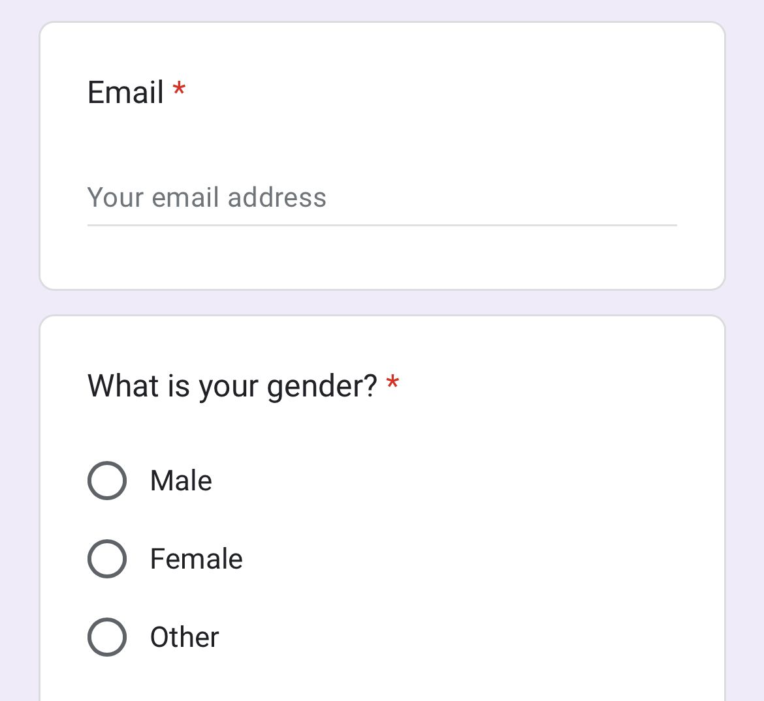

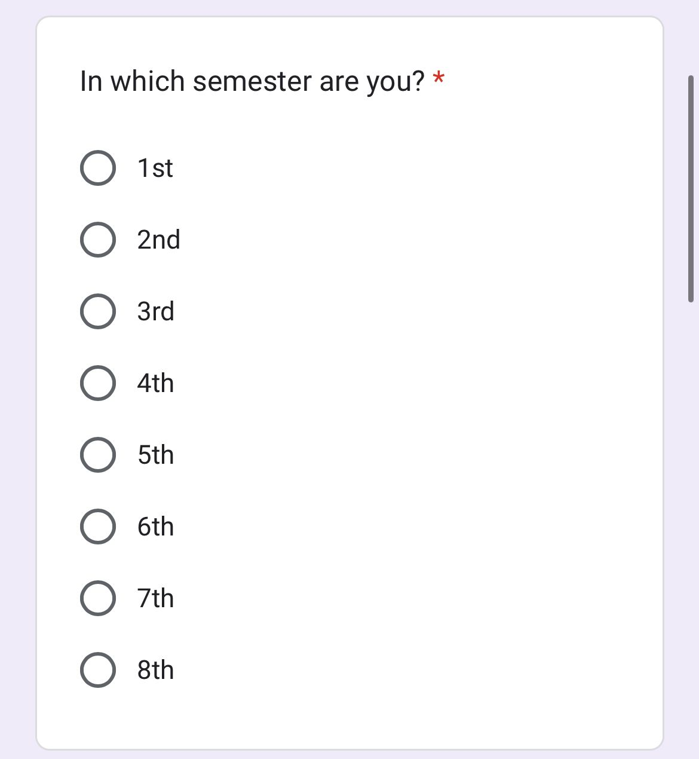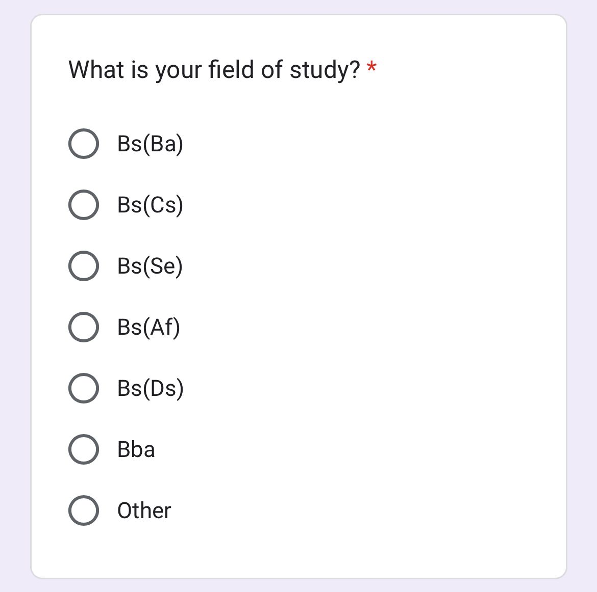

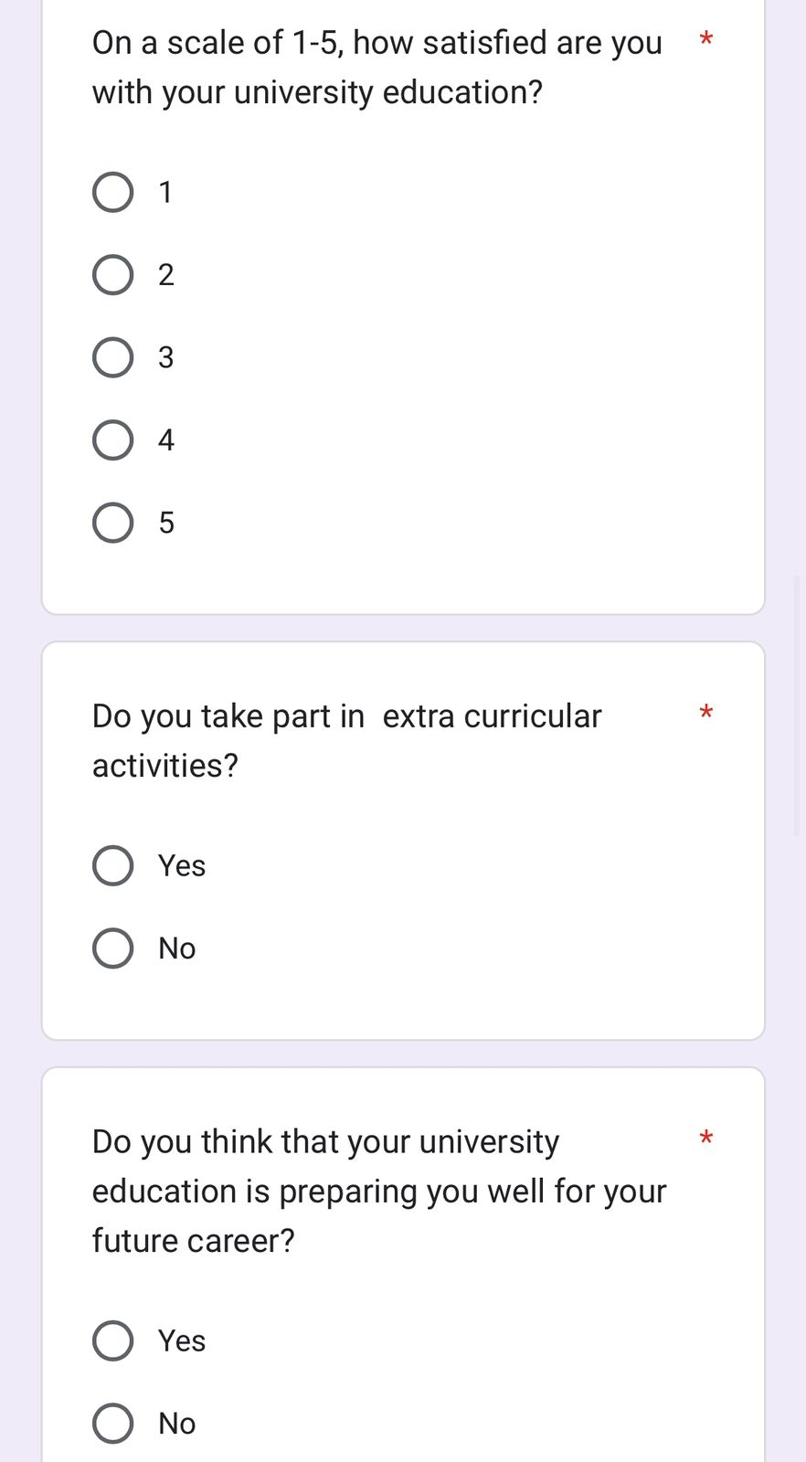

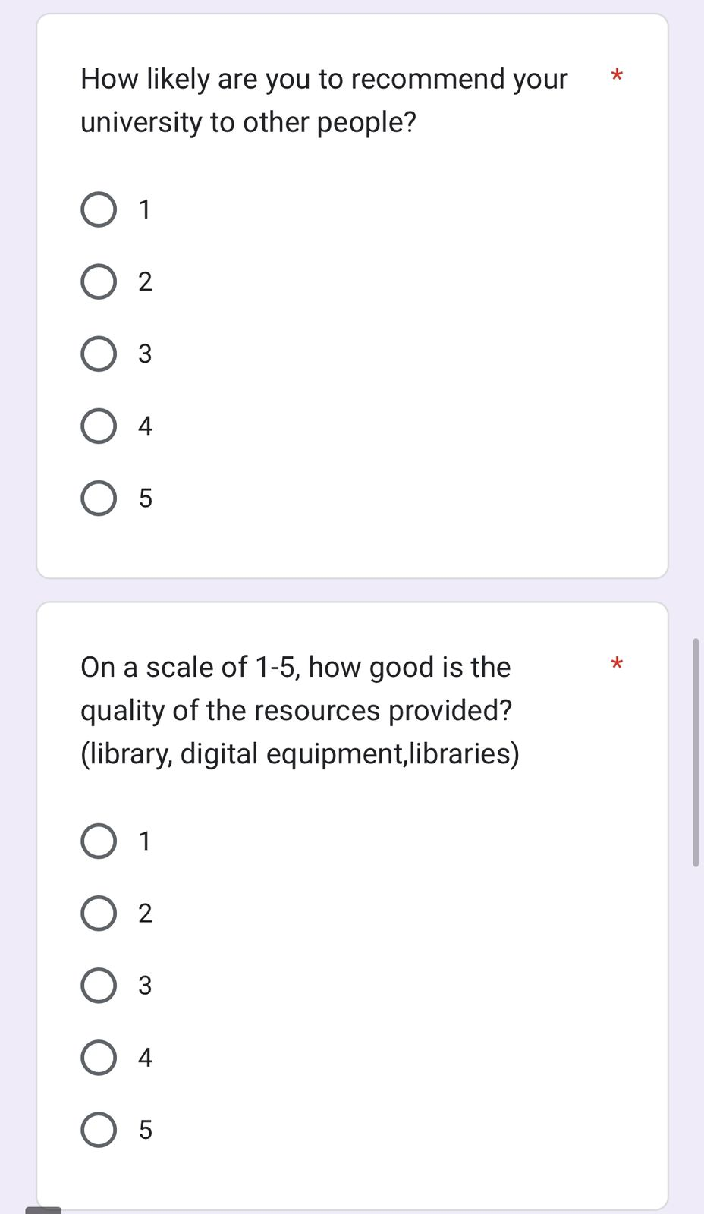





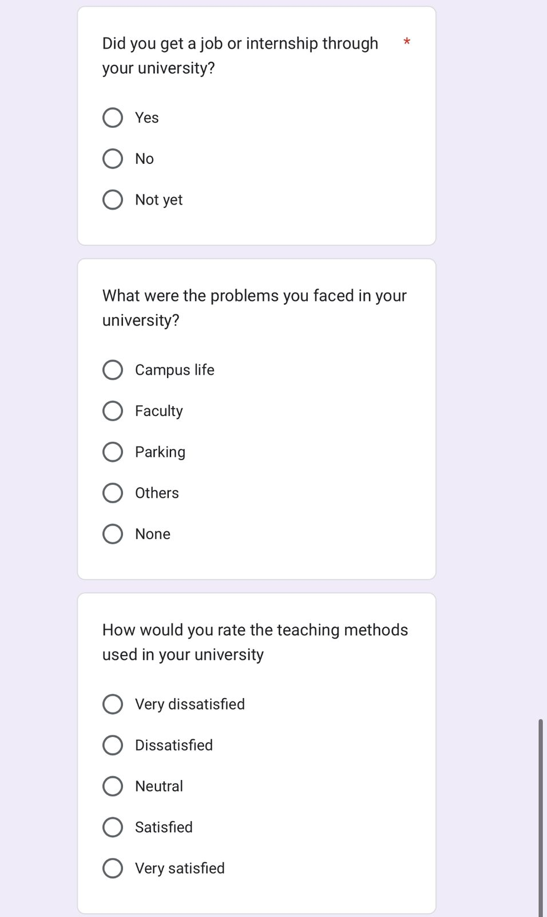

Sample of 5 questionnaire

